Data Buoy Cooperation Panel : Scientific and Technical Workshop XVII
Perth, Western Australia, 22, 23 October 2001

The South Australian Wave Rider Buoy and

Some Preliminary Comparisons of Wind and Wave Data.

Andrew Watson
Supervising Meteorologist, Bureau of Meteorology, South Australian Regional Office

Abstract

The first wave rider buoy to be operated by the Bureau of Meteorology in South Australian coastal waters was deployed in November 2000. The buoy is moored to the ocean floor in 80 metres of water, 4 nautical miles west of Cape du Couedic on Kangaroo Island. It is a conventional wave rider, comprising a spherical stainless steel casing, which houses an accelerometer sensor, process circuitry and a High Frequency (HF) transmitter. When the buoy moves in response to a passing wave, variations in voltage are transmitted to a processor which translates them into vertical accelerations and then to wave heights and periods.

Buoy deployment was a joint project between the Bureau and Lawson and Treloar Pty Ltd, with contracted assistance from a Kangaroo Island fisherman. The buoy uses HF radio transmission to send wave data every 26 minutes to a base station at Cape du Couedic. A personal computer at the base station which logs the transmitted data is polled at regular intervals by staff at the Adelaide Regional Weather Forecast Centre. This system provides high resolution wave data to Australian weather forecasters in near real time via the Bureau’s Intranet. Hourly data extracted from the full data set is provided to the general public through the Internet.

Wave data derived from the buoy includes significant wave height (mean height of the highest ¹/₃ of waves in a 26 minute sampling period), maximum wave height, the period of all waves and the period of the dominant waves in each sample.

All recorded wave data from March to August 2001 inclusive was analysed. Mean significant wave heights showed little variation from March to July with an average height of 2.6 metres, but increased to 3.4 metres in August. Wave height ranged from a minimum significant height of 0.8 metres to a maximum of 13.8 metres.

Half hourly wind data from the nearest automatic weather station (Neptune Island, 50 nautical miles northwest of the buoy) for the same period was correlated with wave data from the buoy. Mean wind speed (10 minute average) showed little variation from March to July, but was 25% stronger in August with the average for all months being 16 knots (30 kilometres per hour). Wind speed ranged from calm to 44 knots, and was positively correlated (R = 0.37) to significant wave height. The strength of the correlation was dependent on the wind direction. Winds from the westerly (310⁰ to 230⁰) and southerly (220⁰ to 140⁰) sectors were generally more strongly correlated to significant wave height (R = 0.45), although there was notable month to month variation. In contrast, winds from the easterly (130⁰ to 050⁰) to northerly (040⁰ to 320⁰) sectors showed almost no correlation to significant wave height (R = 0.02), with some months actually negatively correlated.

For winds from the westerly and southerly sectors, the average significant wave height (3.2 metres) was around 1 metre higher than the average height for the other two sectors (2.2 metres). On the assumption that the height of the locally generated wind waves should be independent of wind direction, the implication is that winds which have an oceanic fetch are generally associated with a swell wave component which is not apparent when the winds are of continental origin.

These preliminary results provide some insight into the wave climatology of the area west of Kangaroo Island, and have implications on wave forecasting for coastal waters of South Australia. Further analysis of data from the wave rider buoy is planned, with the main aim being to produce a more comprehensive comparison between wind speed and direction and wave height, for application in operational forecasting.

1. Introduction

The Wave Rider Buoy, manufactured in the Netherlands by Datawell, is recognised as an international standard sensor for ocean wave measurement. Wave rider buoys are typically used in coastal waters in depths ranging from 10 to 200 metres. In Australia, wave rider buoys are used mostly to provide deep water wave data. Buoys are typically moored in a water depth of 80 to 100 metres, between 3 and 6 nautical miles (5 to 12 kilometres) from the shoreline. Several wave riders are currently operating in Australian coastal waters, mostly along the east coast of the continent.

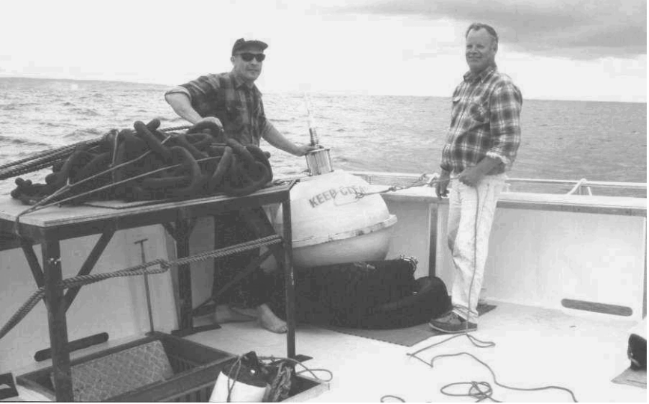
The Bureau of Meteorology has for some time seen a need for wave data from the Southern Ocean, immediately to the south of the Australian continent. The Observations and Engineering Branch of the Bureau approached the South Australian Region with an offer to part fund a wave rider buoy, and assist in its transport and deployment. The South Australian Region then approached interested external businesses and agencies seeking the additional funding required for the buoy project. Two State Government agencies agreed to provide funds toward the project, enabling a wave rider unit to be purchased from the private company Lawson and Treloar Proprietry Limited.
Figure 1 : Wave rider buoy on board deployment vessel

Deployment was completed in November 2000 (Figure 1), through a cooperative effort involving the Bureau’s South Australian Regional Office, Lawson and Treloar and a commercial fisherman from Kangaroo Island. A fishing vessel owned and operated by the fisherman was used to transport the buoy and mooring components to the point of deployment.
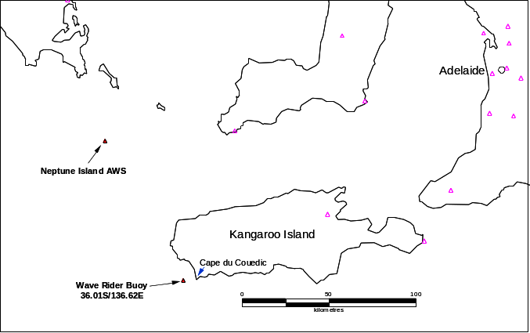
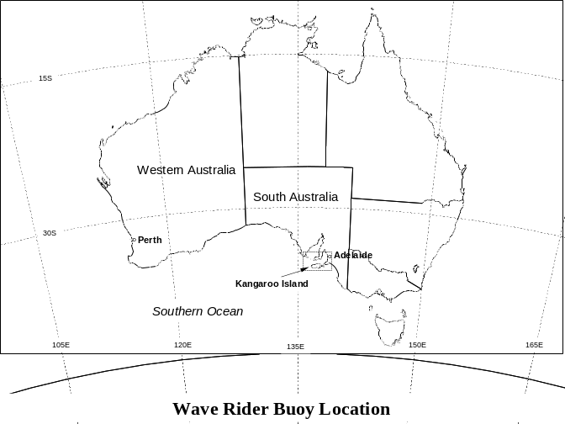
Figure 2b : Wave rider buoy location relative to South Australian coast
Figure 2a : Wave rider buoy location relative to Australian continent

A suitable deployment point was found at a location 4 nautical miles (8 kilometres) west of Cape du Couedic, the southwest extremity of Kangaroo Island, South Australia (Figure 2). The buoy and mooring were deployed in water 80 metres deep. The mooring comprises a length of stainless steel chain and shackle fixed to the base of the buoy, connected in turn to a rubber shock cord, poly-line, stainless steel cable and a 300 kilogram anchor weight of stud-link chain. The total length of the mooring is approximately 150 metres – around twice the water depth. The rubber shock cord ensures the buoy is free to follow the sea surface as waves travel past. The anchor weight secures the mooring to the ocean floor.

Wave Rider Buoy Description

The “body” of the wave rider buoy comprises a stainless steel spheroid, which houses an accelerometer sensor, process circuitry and a High Frequency (HF) transmitter. A two metre long whip antenna is attached to the “top hatch” on the top side of the buoy.
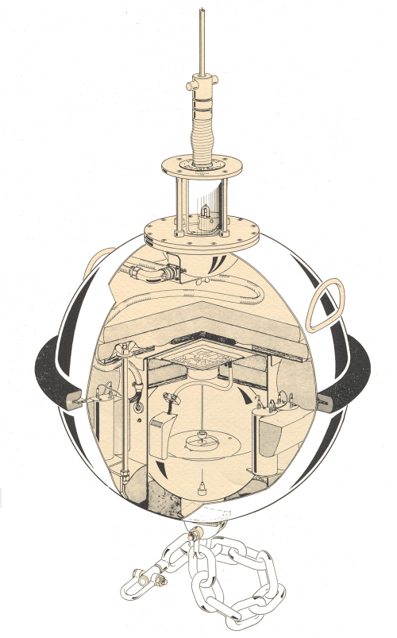
Figure 3 : Wave rider buoy components
The “heart” of the buoy (Figure 3) is a weighted “platform” which is suspended by a two axis gimbal (similar to a compass on a ship) in an electrolytic fluid. This set-up allows the platform to remain horizontal within the buoy, at least for short period durations typical of sea wave motion. A flexible bar is attached to the platform. The free end of this bar attempts to remain in the same position due to its inertia but the fixed end of the bar moves up and down along with the platform. When the buoy accelerates in response to a passing wave, the free end of the bar moves relative to two fixed electrodes and senses variations in its voltage relative to the electrodes. These variations in voltage are transmitted to a processor which translates them into vertical accelerations and ultimately into wave heights and wave periods.

Whilst the buoy system provides detailed information on wave height characteristics, it cannot provide information on the direction of travel of waves. It is therefore not possible to discriminate either the direction of movement of local wind produced waves, or the direction from which the longer period swell waves come.

3. Communication System

Data transmission is via HF radio (27.7 Mega-Hertz) to a receiving station just to the north of Cape du Couedic. Transmissions from the buoy are made at 26 minute intervals, with the data from the buoy recorded by an on-site personal computer at the receiving station. When this computer is polled by staff at the South Australian Regional Forecast Centre (RFC) in Adelaide, the data are re-transmitted to a nearby repeater station, which is connected directly into the telecommunications landline. Data is polled at regular intervals, and once received in the RFC is displayed on terminals in both graphical and tabular format for use by weather forecasters. The full resolution graphical wave data is sent to the Internet and available via registered user password access to the agencies that contributed funds toward the project. Tabular data at approximately hourly intervals are available to the general public.

4. Data Description

Prior to deployment of this wave rider buoy, real time remotely sensed wave data from South Australian coastal waters had not been available to forecasters. Observations of the characteristics of waves in South Australian waters have traditionally been provided via visual reports from cooperative observers at a few coastal locations. The value of these observations has always been limited by their infrequency (3 hourly at best), and their quality, with observations often compromised by reduced daytime visibility or night-time darkness.

Data provided by the buoy software system includes significant wave height (H_{s}), maximum wave height (H_{max}), average period of all waves (T_{z}), and peak energy period (T_{p}) (the period of the dominant waves in the spectrum). Significant wave height (average height of the highest ¹/₃ of waves in the spectrum) is the most useful information to the marine weather forecaster in the provision of coastal waters forecasts, and it is these data which are examined in this paper.

Since deployment, wave observations from the buoy have been acknowledged by forecasters as very valuable information in the assessment of the state of the sea to the waters west of Kangaroo Island. These data provide objective guidance for sea state forecasts and are also a basis for the verification of numerical model wave forecasts.

5. Data Analysis

All wave data received from the buoy in the six month period from March to August 2001 inclusive were recorded, and H_{s} data extracted from this data set. In an endeavour to gain an improved understanding of the relationship between wind and waves in South Australian coastal waters, these wave data were correlated with wind data for the same period from the Bureau’s Automatic Weather Station (AWS) on South Neptune Island (Figure 1), a small island 50 nautical miles (93 kilometres) to the northwest of the buoy.

The assumption used for this analysis to be valid was that the wind conditions at Neptune Island were the same as those experienced at the site of the buoy. This assumption is probably not strictly valid since it is likely that at times during the six month period, wind conditions between the two sites would not have been identical. However, it is unlikely that any inter-site variations in wind would have persisted for long enough or would have been of sufficient magnitude to affect the overall results.

Data from the Neptune Island AWS are received and recorded at the South Australian RFC at 30 minute intervals. Every 30 minute wind record from March to August inclusive was correlated with the wave data record from the buoy nearest in time. Because the time intervals between wind data and wave data transmissions did not match exactly, there was often a small time difference between the respective records. To minimise the time discrepancy the data sets were filtered to ensure that there was never a difference of more than 15 minutes between a wind data record and its matching wave data record.

Analysis of the wave data (Table 1) showed that for the months from March to July inclusive, there was little variation in mean monthly significant wave height. During May the mean H_{s} was 2.3 metres, ranging up to a mean of 2.8 metres in April. For the same period, there was little variation in mean (10 minute average) wind speed, ranging from 13.6 knots (25.3 kilometres per hour) in April to 15.5 knots (28.7 km/h) in both June and July. Significant wave height (H_{s}) ranged from a minimum of 0.8 metres to a maximum of 11.2 metres, both observed during May. Mean wind speed ranged from calm on several occasions to 44 knots (81.5 km/h). Wave height and wind speed for these 5 months were positively correlated (correlation coefficient R = 0.35), although there was significant month to month variation. Strongest correlation was in May with R = 0.65, ranging downward to R = 0.04 for April.

Month | Mean H_{s}  (metres) | Mean Speed (knots) | Correlation  (R)
March | 2.6 | 15.3 | 0.43
April | 2.8 | 13.6 | 0.04
May | 2.3 | 15.1 | 0.65
June | 2.7 | 15.5 | 0.16
July | 2.5 | 15.5 | 0.45
August | 3.4 | 19.4 | 0.47
Table 1 : Monthly means of H_{s} , wind speed and correlations.

In contrast to the previous five months, a notable increase in both wind speed and wave height occurred during August, but there remained a positive correlation (R = 0.47). Mean wind speed was 19.4 knots (35.9 km/h) with a corresponding mean H_{s} of 3.4 metres. The maximum wave height in the entire data set of 13.8 metres was recorded during August, this coincident with a period of sustained 35 to 40 knot (65 to 75 km/h) westerly winds.

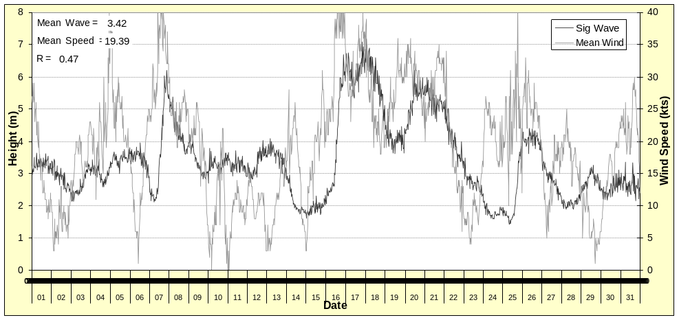
Graphical time series plots of wind speed and significant wave height (Figure 4) illustrated the variation of both wind speed and direction with wave height. Whilst there was a positive correlation between wind speed and wave height for each month, it was generally not strong. Inspection of the time series plots revealed that at times, wave height responded to variations in wind speed. There were several clearly indicated instances in the time series where an increase in wind speed resulted in a rapid increase in wave height, with little lag in time. On other occasions however, the lag between wind speed increase and wave response was considerably longer and often weaker. There were also clearly illustrated situations where wind speed increased, but wave height did not – in fact wave height occasionally decreased with increasing wind
Figure 4a : Time series of significant wave height vs wind speed : August 2001

It was surmised that there were other factors operating which influenced the reaction of the sea to wind. Examination of the time series plots of wind direction and significant wave height (Figure 4b) gave some clues into the relationship. When the wind was from the easterly through northerly quadrants (130⁰ to 320⁰) wave height was generally low or decreasing. Winds from the westerly through southerly quadrants (310⁰ to 140⁰) were commonly associated with greater wave height. There was frequently an abrupt increase in wave height as winds shifted from the north to the west – the characteristic wind shift associated with the passage of a cold front.

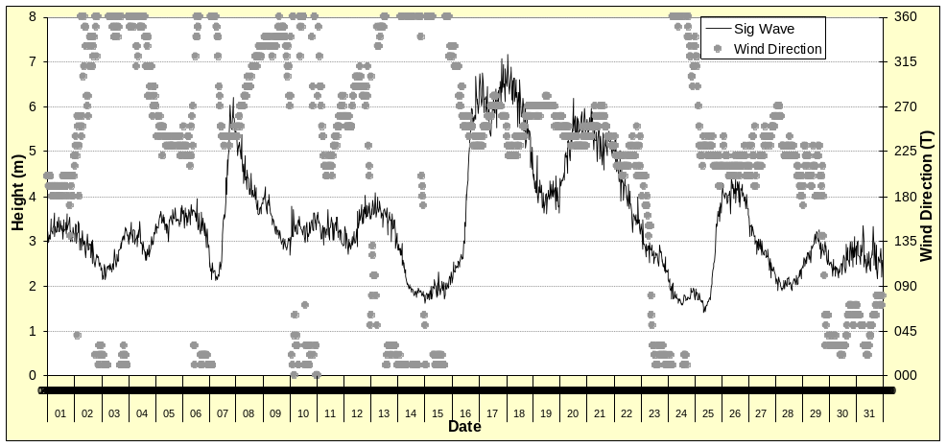
To further examine the effect of wind direction on wave height, wind data was stratified into the four direction quadrants – North (040⁰ to 320⁰), West (310⁰ to 230⁰), South (220⁰ to 140⁰) and East (130⁰ to 050⁰). For each of these quadrants, the monthly distribution of wave height against wind speed was analysed.
Figure 4b : Time series of significant wave height vs wind direction : August 2001

The normal seasonal wind climatology of the region is illustrated by these analyses (Table 2 and Figure 5) which show that in each of the six months analysed the strongest winds occurred from the westerly quadrant. A positive correlation between wind strength and wave height existed (mean R = 0.40) with the highest mean significant wave height (3.3 metres) occurring when the wind direction was from the west.

A similar positive correlation existed for winds from the southerly quadrant (R = 0.47), and even though the mean wind speed was lower (14.6 knots compared to 20.9 knots) than for the westerly quadrant, H_{s} was only slightly lower (3.0 metres).

March |  |  |  | June
Wind Direction Quadrant | Mean H_{s}  (metres) | Mean Speed (knots) | Correlation  (R) | Mean H_{s}  (metres) | Mean Speed  (knots) | Correlation  (R)
Northerly | 2.0 | 14.4 | 0.24 | 2.3 | 15.5 | 0.01
Westerly | 3.4 | 22.6 | 0.42 | 2.9 | 18.0 | 0.35
Southerly | 2.6 | 15.6 | 0.37 | 3.2 | 10.6 | 0.53
Easterly | 2.4 | 13.0 | 0.08 | 2.7 | 10.5 | -0.00
April |  |  |  | July
Northerly | 2.2 | 12.1 | -0.37 | 2.3 | 14.0 | -0.11
Westerly | 3.1 | 15.6 | -0.35 | 3.1 | 21.9 | 0.66
Southerly | 3.0 | 14.2 | 0.13 | 2.9 | 15.4 | 0.46
Easterly | 2.9 | 12.9 | 0.15 | 1.9 | 12.4 | -0.06
May |  |  |  | August
Northerly | 1.3 | 12.3 | 0.00 | 2.7 | 16.7 | -0.23
Westerly | 3.2 | 23.4 | 0.79 | 4.1 | 23.7 | 0.52
Southerly | 3.0 | 15.7 | 0.81 | 3.4 | 15.9 | 0.49
Easterly | 2.0 | 7.8 | 0.31 | 2.8 | 16.6 | -0.40
Table 2 : Monthly correlations of H_{s} with wind speed for the each wind direction quadrant

In contrast, when winds blew from either the northerly or easterly quadrants, wave heights were significantly lower. The mean H_{s} for both the northerly (2.1 metres) and easterly wind quadrants (2.4 metres) was almost 1 metre lower than the wave height for the other two wind quadrants.

This difference could be attributed to the fact that winds from the north and east were generally weaker than those from the west and south (13.1 knots compared to 17.7 knots). However, a most interesting result was that apart from in March (when there was weak positive correlation between wind and wave height for all quadrants), the correlation between wind speed and wave height was either very weak or negative when winds blew from the north or east. This was particularly clear in August when the correlation was quite strongly negative – indicating that significant wave height actually decreased as northerly or easterly wind speed increased.
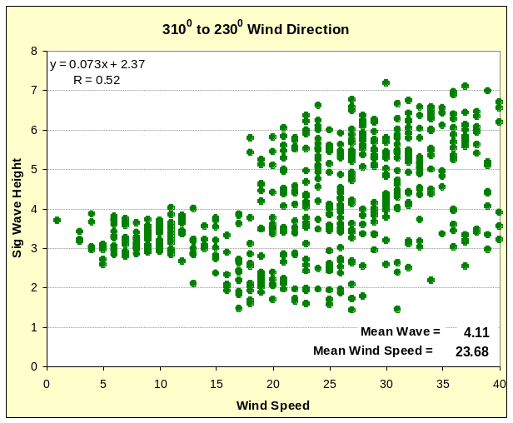
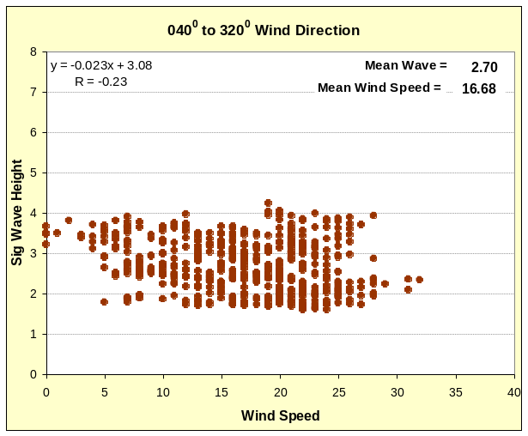
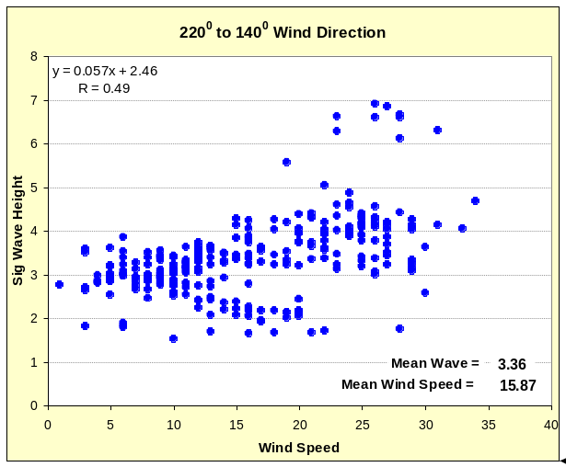
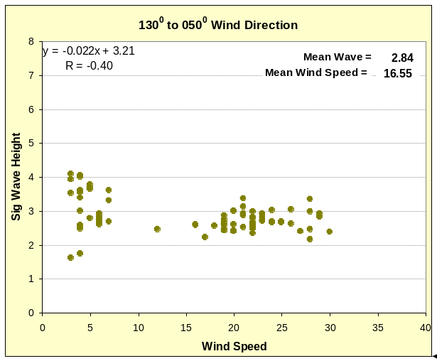
Figure 5 : Wave Height vs Wind Speed for each wind direction quadrant for August. Line segments show the linear fit for the data distribution, with the equation indicated.

Significant wave height is a combination of waves generated by the local wind, and swell waves generated by winds acting over a large marine fetch. The location of this wave rider buoy provides good exposure to winds from all directions, so it is reasonable to expect that locally generated wind waves would increase as wind speed increases. Given that the data shows that in many cases H_{s} did not follow this trend, a reasonable conclusion to be made is that the swell component of waves in the vicinity of the wave rider buoy decreases with time when winds blow from the north or east. There is logic to this in that winds from these directions are of continental origin and have very limited oceanic fetch.

This is a factor which historically has been taken into account on a qualitative basis when forecasters prepare marine forecasts, but which has now been quantified through this comparison of wind and wave data. These results, which provide quantitative information on the variation of wave height in differing wind regimes should add confidence to the decision making of marine forecasters.

In an endeavour to provide easy-to-use objective guidance to assist forecasters in their efforts to forecast wave height in coastal waters, the data were further analysed to determine the mean wave height for a range of wind speeds. For each month and for each of the four wind direction quadrants, wind speed ranges were selected as in Table 3.

Wind Speed Range (knots)
< 7 | 7 - 12 | 12 – 17 | 17-22 | 22-27 | 27 - 33 | > 33
Table 3 : Wind speed ranges for comparison of wave height against wind direction. Note that these wind speed ranges are those commonly used in forecasts for coastal waters.

Graphical representations of this analysis (Figure 6) revealed a similar pattern for each month. The graphs visually confirmed the fact that for the months from March to August significant wave height increased with strengthening winds when the wind blows from the westerly or southerly quadrants. In contrast, they demonstrated that for winds blowing from the east or north significant wave height showed little or no increase as wind speed increased – in fact in some months, including August, H_{s} actually decreased as wind speed increased.
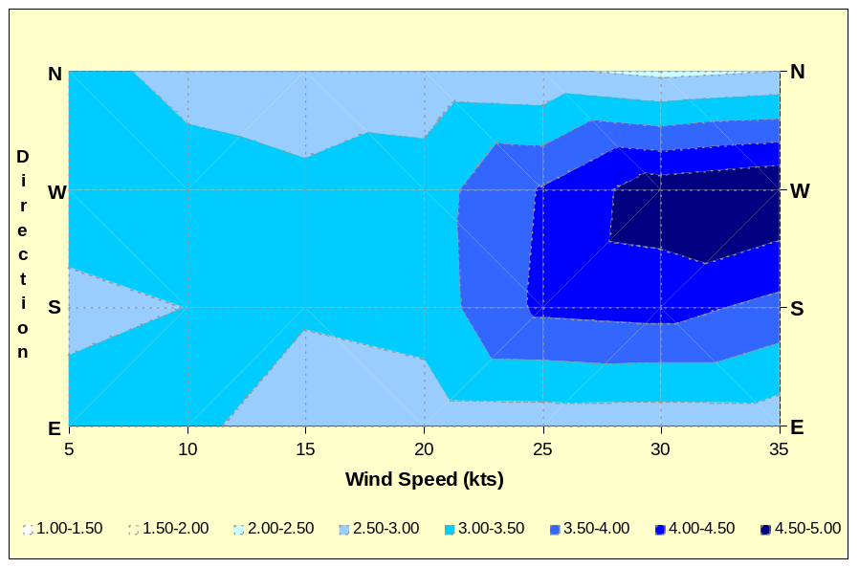
Figure 6 : Wave height vs wind speed and direction for August
Graphical displays such as Figure 6 provide easy to use objective guidance to assist the marine forecast process. In company with numerical output products, such aids can also assist in improving the understanding of the wave climatology of coastal waters, and thus lead to further enhancements in the accuracy of wave forecasts.

As a flow on from this work, further analysis of Neptune Island AWS wind data and wave rider buoy wave data is planned, so that seasonal variation of the wind-wave relationship can be more fully assessed. Ultimately this is intended to lead to a comprehensive climatology, and to serve as objective guidance for South Australian marine forecasters.

5. Summary

The first Bureau of Meteorology wave rider buoy in South Australian waters was successfully deployed off Cape du Couedic, Kangaroo Island in November 2000 and has since provided comprehensive wave data. These data, which include significant wave height, maximum wave height, and wave period has proved to be valuable information to forecasters at the Bureau of Meteorology, to stakeholder State agencies and to the public in general. For the first time, meteorologists can access objective observations on which to base forecasts of wave height. The wave data are also a basis for quantitative verification of forecasts. Logically, this should lead to an improved understanding of the wave climatology of the area, and to improved forecasts of sea state.

In addition to the positive implications for weather forecast operations, the data provided by the buoy provide a basis for research into the characteristics of waves in southern coastal areas of the Australian continent. Through the correlation of wind data from the nearby Neptune Island automatic weather station, this paper has presented preliminary analyses which provide some insight into the relationship between wind and waves in the marine area to the west of Kangaroo Island.

Analysis of six months of data has shown that significant wave height is correlated to wind strength, but that the strength of the correlation is dependent on wind direction. It has been shown that in general, there is little correlation between wind speed and wave height when winds blow from the easterly or northerly quadrants. However, when winds blow from the westerly or southerly directions, there is generally a positive correlation between wind speed and wave height. Waves from these directions were almost a metre higher on average than waves from the other two quadrants.
An suggested explanation for this is that winds from the west and south have a large oceanic fetch and are therefore generally associated with a swell wave component which increases with wind speed. The case is apparently not the same for winds of continental origin. Because of the limited fetch over water, there is little or no swell component to add to the locally generated wind wave. In fact, there is evidence that the swell wave actually decreases as continental wind strength increases.

Further analysis of wave rider buoy data is planned, at least to the point where a full year of data has been collected. A more complete comparison of winds and waves should further enhance the understanding of wave climate of the region through the seasons, and provide greater benefit to those involved in the provision of marine forecast services.

6. References

Blair, P.M., 1974. Buoy for Recording Ocean Wave Height and Period. International Symposium on Ocean Wave Measurement and Analysis, American Society of Civil Engineers, New Orleans, September 1974.

Datawell b.v., Laboratory for Instrumentation, 2001 : Internet Site : http://www.datawell.nl, 2001.

Seymour, R., Castel, D., McGehee, D., Thomas, J. and O'Reilly, W., 1993. New Technology in Coastal Wave Monitoring. Second International Symposium on Ocean Wave Measurement and Analysis, American Society of Civil Engineers, New Orleans, July 1993.

Waverider Buoy, Strahan Tasmania, 2001. Engineering Services, Bureau of Meteorology, Tasmanian and Antarctic Region, Intranet Site : http://www.tas.bom.gov.au/reg_progs/maint/tas/ysrn/buoy_index.shtml, 2001.

Wyllie, S.J and Kulmar, M.A., 1995. Coastal Wave Monitoring. Australian Marine Data Collection and Management Guidelines Workshop. Environmental Resources Information Network, Hobart, December 1995.

